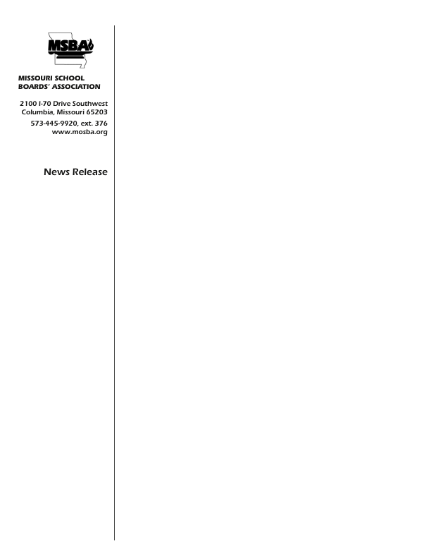

# **October 1, 2019**

**For Immediate Release**

**Contact: Brent Ghan**

**(573) 445-9920, ex. 376**

## Dunklin R-V wins Early Childhood Education Program

## of the Year Award

The Dunklin R-V School District is the recipient of the Early Childhood Education Program of the Year award from FutureBuilders, the educational foundation of the Missouri School Boards’ Association. The award was presented at the 2019 MSBA Annual Conference at the Lake of the Ozarks on September 28. Dunklin R-V was recognized in the category of school districts with an enrollment between 500 and 4,000 students.

The MSBA FutureBuilders Early Childhood Education Program of the Year is designed to reward public school districts that have implemented programs to advance quality early educational opportunities for children.

To be eligible for the Award, the school district must be a member of Missouri School Boards' Association and must offer a high quality pre-kindergarten program. Award recipients were selected by the MSBA FutureBuilders Board based on their innovative approaches and outstanding ability to engage and support the development of the children in their care and on their overall commitment to early childhood education.

The Missouri School Boards’ Association is a private, not-for-profit organization that exists to help school boards succeed.

##